**Hospital Management System**

**About Project**

Hospital Management System is based on a concept of recording normal and critically ill patient records of different categories. In this system, there are no login features. The user can easily select various clinic types where he/she can register a patient, take the patient to a doctor, and view total patient list. This mini project contains limited features, but the essential one.

Talking about the features of the Hospital Management System, in total there are four departments. They are General Clinic, Heart Clinic, Lung Clinic, and Plastic Surgery. At first, the user has to select their department to proceed. Each of the department contains essential features required for a hospital, such as adding normal and critically ill patient, taking the patient to doctor, and displaying the total list of patient details. In order to add normal and critically ill patient, he/she has to enter the patient’s name, gender, age, blood group, and contact details. The patients can be taken to the doctor for this, the user just has to select the patient. It also removes the patient details from the list.

**Remaining Feature:**

And the last feature of this project is displaying a list of the registered patient. It displays all the available details of the patient such as first and last name, gender, age, blood group, and contact details.  The system does not use any external files to store the data permanently. Hospital Management system is developed using C++ Programming Language and different variables, strings have been used for the development of it.

**Snapshot:**

Entry page with different tasks.

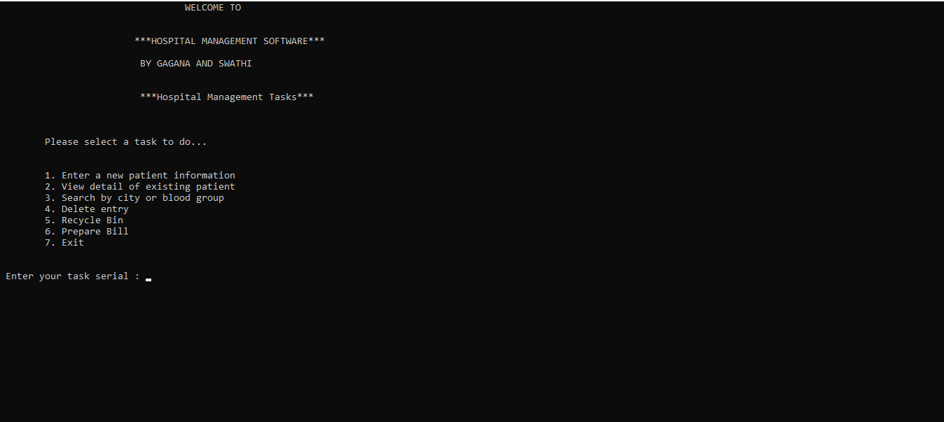

After entering ,Enter a new patient information.

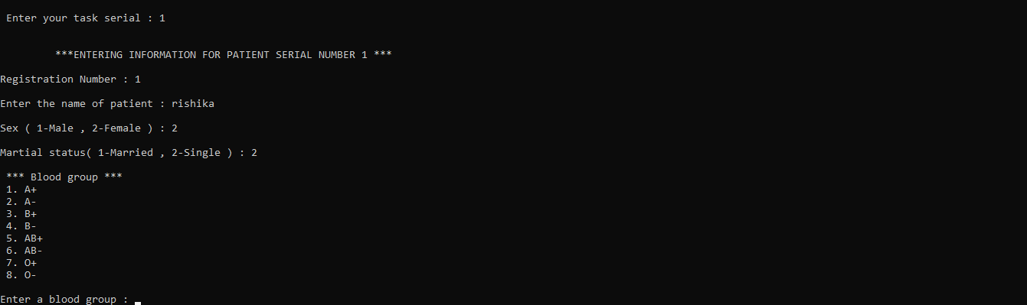

View detail of existing patient.

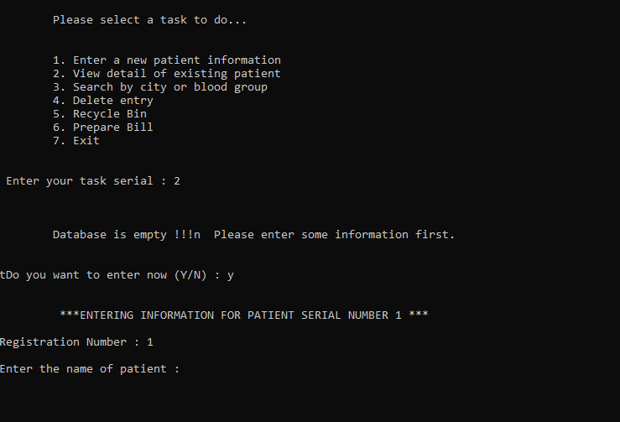

Search by city or blood group.

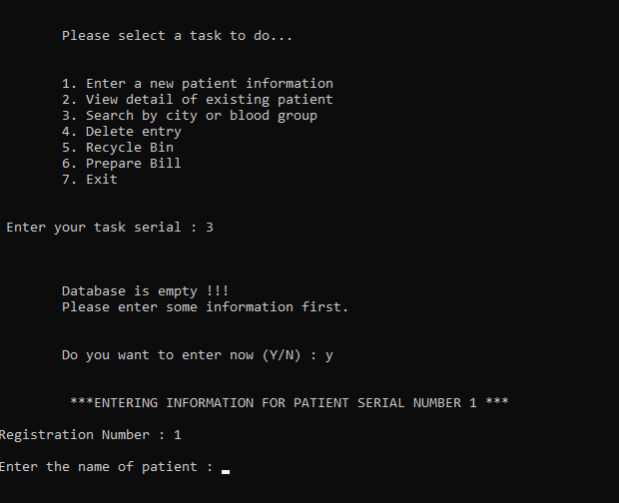

Prepare bill.

